Aim: Create a simulation for FTP service.

# Requirements:

* Window operating system
* Cisco software
* 2 router
* 2 switch
* 3 pc
* 1 Server
* Cross over cable
* Straight through cable

Step 1: Go to the Cisco and take 2 router, 2 switch, 3 pc, 1 Server, cross over and straight through cables.

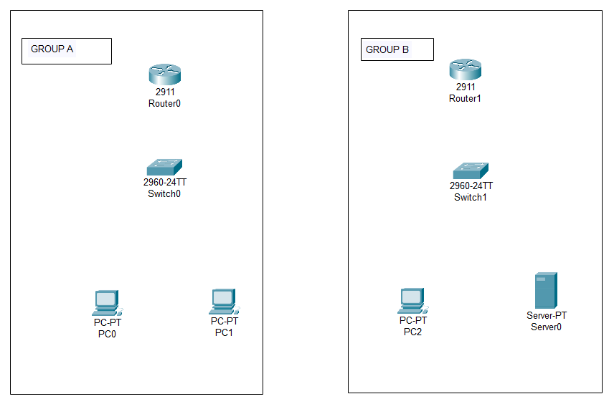

Step 2: Do connection with the help of straight through into the group a and group b and connect the both router with cross over cable.

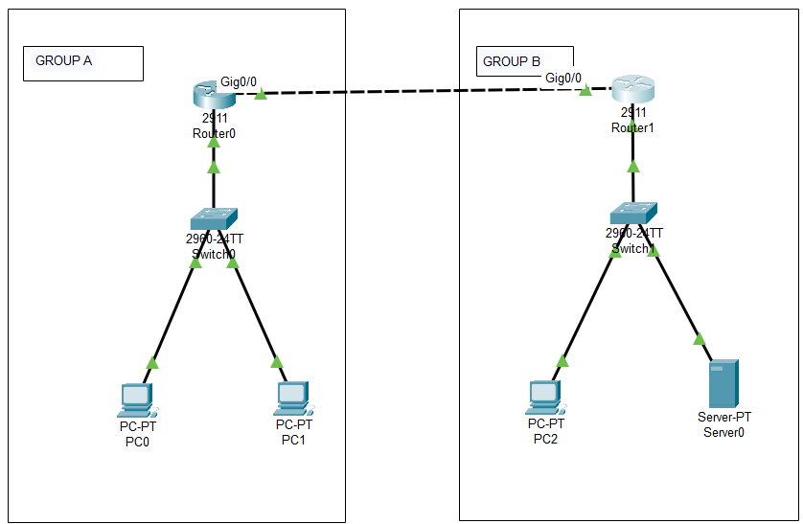

Step 3: Click on router then go to the config then give the ip as follow

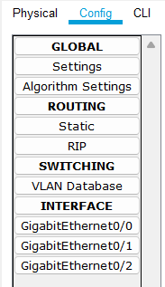

GROUP A

* Router—10.0.0.1 (gig0/1)

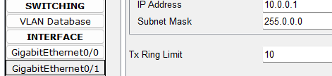

* Router--- 30.0.0.1 (gig0/0)

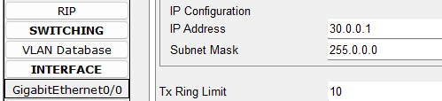

GROUP B

* Router – 20.0.0.1 (gig0/2)

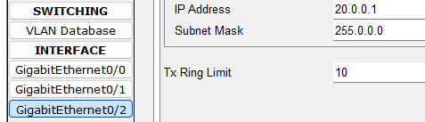

* Router – 30.0.0.2 (gig0/0)

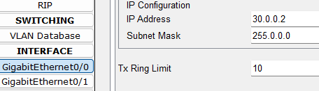

Step 4: go to the desktop then ip configuration after it give the ip as follow into the both group. Also give the server ip.

* Pc 0 – 10.0.0.2 (gateway 10.0.0.1) (server 20.0.0.3)
* 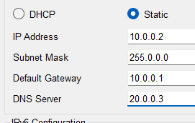
* Pc 1 – 10.0.0.3 (gateway 10.0.0.1) (server 20.0.0.3)
* Pc 2 – 20.0.0.2 (gateway 20.0.0.1) (server 20.0.0.3)
* Server – 20.0.0.3 (gateway 20.0.0.1) (server 20.0.0.3)

Step 5: do the RIP into the both routers.

GROUP A

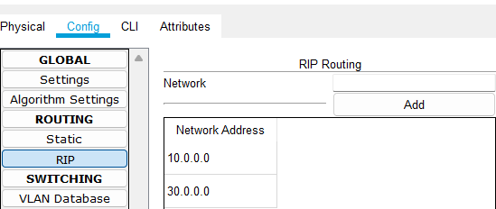

GROUP B

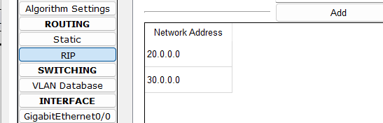

Step 6: Know go to the server then go to the services. Then go to the FTP.

Give the username, password and all rights then click on add.

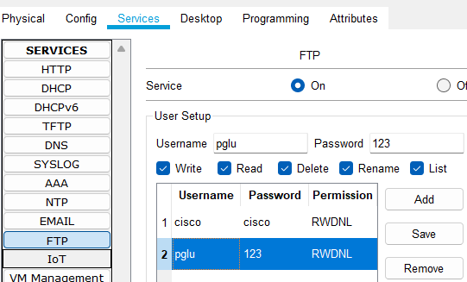

Step 7: Go to the pc 1 and click on the txt editor create a txt file.

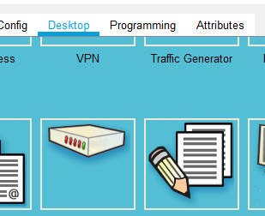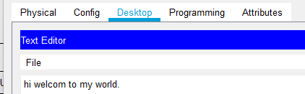

Step 8: Go to the command prompt and follow the cmd.

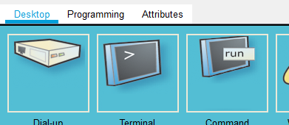

* Dir (show the available file)

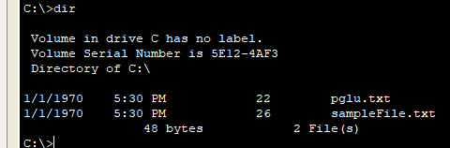

* ftp (access the server)

ftp 20.0.0.3 (20.0.0.3 is server ip)

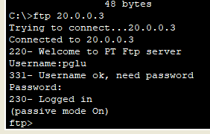

* Put (upload the file on server)

put pglu.txt

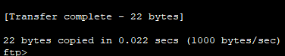

Step 9: Go to the pc 2 then go to the command prompt type as follow cmd.

* ftp

ftp 20.0.0.3 (20.0.0.3 is server ip)

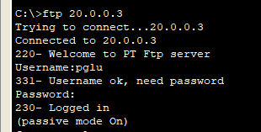

* get

get pglu.txt (get used for download a file and here pglu.txt is file)

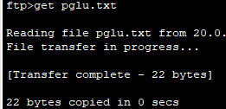

* dir (show the available file)

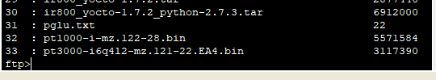

Here we are complete FTP services.